Lazy Learning

What is Lazy Learning?
Lazy learning refers to machine learning processes in which generalization of the training data is delayed until a query is made to the system. This type of learning is also known as Instance-based Learning. Basically, Lazy learning systems just store training data or conduct minor processing upon it and they wait until test tuples are given to them. Lazy classifiers are very useful when working with large datasets that have a few attributes.

Learning systems have computation occurring at two different times:
Training time: it is the time before the consultation time. During training time, the system derives inferences from training data to prepare for the consultation time.
Consultation time: it is the time between the moment when an object is presented to a system so that the system can make an inference and the moment when the system finishes making the inference.
In lazy learning algorithms, most of the computation is done during consultation time. Essentially, a lazy algorithm defers the processing of examples till it receives an explicit request for information.
Lazy Learning vs Eager Learning

Eager Learning | Lazy Learning
When a machine learning algorithm builds a model soon after receiving training data set, it is called eager learning. It is because when Eager Learners are given a set of training tuples, the first thing they will do is to construct a generalization model before receiving new tuples to classify. | When a machine learning algorithm does not build a model immediately after receiving the training data, rather waits till it is provided with an input data to evaluate, it is called lazy learning. That is, when given a training tuple, a Lazy Learner simply stores it and waits until it is given a test tuple. Basically delaying the building of a model until it is absolutely necessary.
Eager Learning systems have a high training time and a low consultation time. | Lazy Learning systems have a low or non-existent training time and a high consultation time.
The system needs to commit to a single hypothesis that covers the entire instance space. | Systems can make use of a richer hypothesis space because it employs multiple local linear functions to form its implicit global approximation to the target function.
Essentially, eager learning methods create a general, explicit description of the target function, based on the training examples provided | Lazy learning essentially postpones generalizing beyond the data stored until an explicit request is made.
Ex: Decision Tree, Logistic Regression. | Ex: KKN (K Nearest Neighbours), Case Based Reasoning.

When making a classification or numeric prediction, lazy learners can be computationally expensive. They require efficient storage techniques and are well suited to implementation on parallel hardware. They offer little explanation or insight into the data’s structure. Lazy Learners, however, naturally support incremental learning. They are able to model complex decision spaces having hyperpolygonal shapes that may not be as easily describable by other learning algorithms.

KNN
K Nearest Neighbors is the supervised machine learning algorithm used for classification and regression. It manipulates the training data and classifies the new test data based on distance metrics. It finds the k-nearest neighbors to the test data, and then classification is performed by the majority of class labels. So basically, the KNN algorithm determines the target value of a new data point or instance by comparing it with existing data points or instances that are closest to it.
Take a classification task, for example. You want to predict if the glass breaks or not, so you take the majority vote of all k-neighbors. If k=5 and in 3 or more of your most similar experiences the glass broke, you go with the prediction “yes, it will break”.
Let’s now assume that you want to predict the number of pieces a glass will break into. In this case, we want to predict a number which we call “regression”.
Now, you take the average value of your k-neighbors’ numbers of glass pieces as a prediction or score. If k=5 and the numbers of pieces are 1 (did not break), 4, 8, 2, and 10 you will end up with the prediction of 5.
Distance Metrics
The distance metric is the effective hyper-parameter through which we measure the distance between data feature values and new test inputs. Lets see some of the commonly used metrics:
- Minkowski Distance
Minkowski distance is a distance measured between two points in N-dimensional space. It is basically a generalization of the Euclidean distance and the Manhattan distance. It is widely used in the field of Machine learning, especially in the concept to find the optimal correlation or classification of data.
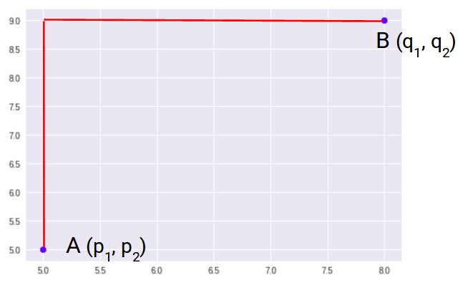
The formula for Minkowski Distance is given as:
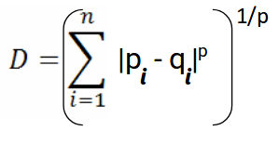
- Euclidean Distance
The Euclidean distance between two points in the Euclidean space is defined as the length of the line segment between two points. As the Euclidean distance can be found by using the coordinate points and the Pythagoras theorem, it is occasionally called the Pythagorean distance. The Euclidean distance formula helps to find the distance of a line segment. Let us assume two points, such as A(p₁, p₁) and B(q₁, q₂) in the two-dimensional coordinate plane.
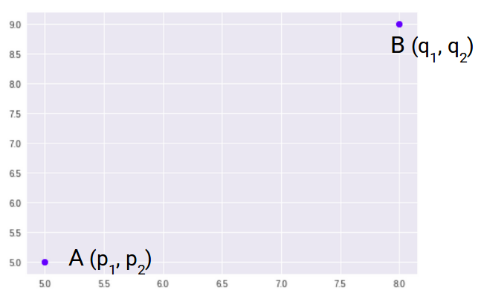
So, the Euclidean Distance between these two points A and B will be:
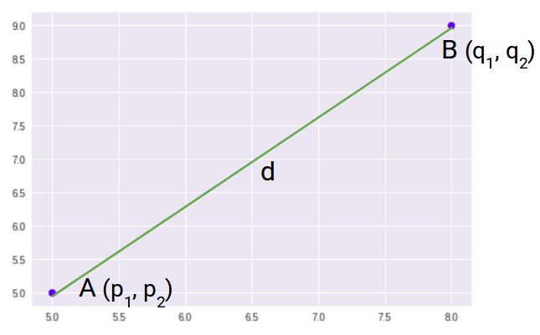

Here’s the formula for Euclidean Distance:
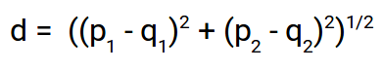
We use this formula when we are dealing with 2 dimensions. We can generalize this for an n-dimensional space as:
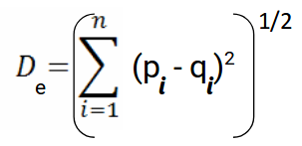
- Manhattan Distance
Manhattan Distance, also known as city block distance, is the sum of absolute differences between points across all the dimensions.
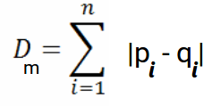
How to select the optimal value of k in KNN

In KNN, finding the value of k is not easy. A small value of k means that noise will have a higher influence on the result and a large value make it computationally expensive. Data scientists usually choose as an odd number if the number of classes is 2 and another simple approach to select k is set k=sqrt(n).

Why is KNN called a Lazy Algorithm??
KNN is called a lazy learner because when we supply training data to this algorithm, the algorithm does not train itself at all. KNN does not learn any discriminative function from the training data. But it memorizes the entire training dataset instead. There is no training time in KNN. Each time a new data point comes in and we want to make a prediction, the KNN algorithm will search for the nearest neighbors in the entire training set. Basically Updating distance metrics with every iteration is computationally expensive, and that’s why KNN is a lazy learning algorithm. Hence the prediction step becomes more time-consuming and computationally expensive.

